**PHD SYNOPSIS**

**Name of the candidate:** Dr. Biju Viswanath

**Name of the Department:** Department of Psychiatry

**Date of registration**: 07-07-2014

**Title of Thesis:** Derivation and characterization of oligodendrocytes from patients with neurodevelopmental disorders

**Name and designation of the guide:**

Dr. Mathew Varghese

Professor

Department of Psychiatry

NIMHANS

**Name of joint guide**:

Dr. Sanjeev Jain

Professor

Department of Psychiatry

NIMHANS

**Name of joint guide**:



Dr. Sumantra Chattarji

Professor

Centre for Brain Development and Repair,

National Centre for Biological Sciences, Bangalore

**Name of joint guide**:



Dr. Siddharthan Chandran

Professor

Centre for Brain Development and Repair, National Centre for Biological Sciences, Bangalore & Director, Centre for Clinical Brain Sciences, University of Edinburgh, United Kingdom.

**Name and designation of Head of Department:**

Dr. Prabha S Chandra

Professor

Department of Psychiatry

NIMHANS

**Name and designation of Dean:**

Dr. S. K. Chaturvedi

Dean of Faculty (Behavioural Sciences) and Professor

Department of Psychiatry

NIMHANS

|  |  |  |
| --- | --- | --- |
|  | **Table of contents** |  |
| **Section** | **Title** | **Page No.** |
| 1 | Introduction | 3 |
| 2 | Aim & Objectives | 7 |
| 3 | Material and methods | 8 |
| 4 | Results and Discussion | 14 |
| 5 | Summary | 27 |
| 6 | References | 28 |

***DERIVATION AND CHARACTERIZATION OF OLIGODENDROCYTES FROM PATIENTS WITH NEURODEVELOPMENTAL DISORDERS***

**INTRODUCTION**

Neurodevelopmental disorders are characterized by deficits in cognition, communication, behaviour, and/or motor skills that occur due to abnormal brain development. The broad umbrella of neurodevelopmental disorders covers intellectual disability, communication disorders, autism spectrum disorder (ASD), attention deficit/hyperactivity disorder (ADHD) and schizophrenia (1). In the absence of clear biomarkers, the differentiation of various neurodevelopmental disorders is based on clinical presentations. However, considerable overlap in symptom clusters exists across these disorders. This has driven research to explore for commonalities in causation including genetics, proteomics, neurophysiology, and neuroanatomy.

Explorations into aberrant brain myelination is one such research direction. Myelination in humans begins in the third trimester of gestation and continues into adolescence and early adulthood (2). The long duration required for the human brain to be myelinated and the differential rates of myelination that occur across various brain regions, could account for the wide range of symptoms and variations in age of onset seen across the neurodevelopmental disorders.

Oligodendrocytes are responsible for myelin production along the axons (3). They also have the most signiﬁcant turnover among all cell populations in the central nervous system and all stages of precursor cells exist in the CNS throughout adult life (4). The development of oligodendrocytes in humans begins during the second trimester of gestation, progressing towards birth, and further into adulthood (5-8). In addition to myelination, oligodendrocytes have also been implicated in other brain functions including synaptic regulation, signalling at the nodes of Ranvier (9-12), and metabolic support of axons (13, 14).

Since myelination occurs along the axons, away from the neuronal cell body, post-transcriptional control of gene expression is believed to play an important role in fine-tuning the overall regulation of protein contents in situ. Research has hence focused on identifying RNA binding proteins and their regulatory mechanisms in myelination. The fragile X mental retardation protein (FMRP) is one such protein regulating target expression through translational control. In addition to neurons, FMRP has also been found in oligodendrocytes, where its functions are still being researched.

Fragile X syndrome (FXS) is the most common monogenic cause of autism resulting from the loss of the FMRP gene and primarily affects males. The full-blown syndrome is typically described in homozygous males. However, recent research has shown that, hemizygous males tend to display greater degrees of autistic behaviours while female carriers have higher rates of schizophrenia spectrum and affective disorders (15), indicating the involvement of a wider neurodevelopmental spectrum.

Hence, the abnormalities in white matter and myelination/oligodendrocytes found in fragile X syndrome, could have mechanistic and pathological implications for other neurological and psychiatric disorders of neurodevelopmental origin.

FMRP has been shown to be expressed in oligoprogenitors and oligodendrocytes in rodents (16, 17) and in myelinating oligodendrocytes from human gestational tissue (16). Its absence causes reduction in the number of oligoprogenitors and delayed myelination in rodents (18). The influence on myelination is possibly mediated through its binding with myelin basic protein (MBP) mRNA (16, 17, 19, 20). White matter defects have been demonstrated in diffusion tensor imaging (DTI) studies in both FMR1 knockout mice (21) and humans with FXS (22-25) as well as premutation carriers (26-31), providing indirect evidence for oligodendrocyte dysfunction in fragile X syndrome.

The next step in establishing this hypothesis is to obtain direct evidence through examination of oligodendrocytes. This warrants cell-line approaches as diseases of the brain cannot be assessed by routine examinations. The neural/glial tissue is separated by a barrier which is impenetrable, and live sampling of such tissues is impossible. In addition, post-mortem brain is generally not suitable for culture or in vitro experiments. Hence, developing cell models offers a viable approximation for better understanding and possible interventions in these syndromes. Advances in cellular re-programming now enable the direct study of oligodendrocytes derived from reprogrammed patient fibroblasts/lymphocytes. Neural conversion and subsequent generation of oligodendrocyte lineage from reprogrammed stem cells is an established invitro laboratory procedure (32-38)

The derivation of oligodendrocyte lineage cells using pre-generated and validated induced pluripotent stem cells (IPS) from well characterized patients with fragile X syndrome and unrelated healthy controls, would enable the study of quantitative differences with respect to morphology, physiology, metabolic function, and myelination.

**AIMS & OBJECTIVES**

To derive oligodendrocyte lineage cells using already generated and validated pluripotent stem cells (PS) from patients with fragile X syndrome, in order to address quantitative differences with respect to morphology, physiology, metabolic function, and myelination.

The objectives were as follows:

1. Generation and characterization of oligodendrocytes from human PS.
2. Quantitative comparison of efficiency of specification to (1) OPC (PDGFRa), immature oligodendrocytes (O4) and differentiated (MBP) oligodendrocytes.
3. Comparison of oligodendrocyte morphology between patients and controls
4. Comparison of metabolic function of oligodendrocytes and oligodendrocyte physiology between patients and controls
5. Comparison of the groups with respect to myelination.

**MATERIALS AND METHODS (BRIEF)**

1. *Available pluripotent stem cell lines (PS) and their maintenance/ propagation*

The following pluripotent stem cell lines were available for this work from my co-guide (SC) laboratory: 1) Induced pluripotent stem cells (IPS) from patients with FXS (N=4), 2) Induced pluripotent stem cells (IPS) from controls (N=2), 3) Control Embryonic stem cells (ES), and FMR1 null ES line (*FMR1*-/y) (N=2).

ES and IPS lines were maintained on Matrigel-coated (SLS, 354230; 1 in 60 dilution) plates and with Essential 8 media (A1517001, Invitrogen). Pluripotency was confirmed by expression of pluripotency markers OCT4, SOX2, TRA-1–60 and NANOG. Immunostaining was done by fixing the cells with 4% PFA, washed with PBS and permeabilized with 0.1%Triton X 100 for 15min at RT. The cells were blocked with 1% bovine serum albumin in PBS. Cells were incubated with respective antibodies overnight at 40C. The cells were washed 3X for 10 min with PBS and incubated with corresponding secondary antibodies for 1hr at RT. Nuclei were counterstained with DAPI (4’,6-diamidino-2-phenylindole, Sigma-Aldrich), and coverslips were mounted on slides with FluorSave (Merck, NJ, USA). An Olympus FluoView 1000 microscope was used for fluorescent imaging. Images were processed with ImageJ64 (v 1.47). Regions of interest were selected based on uniform DAPI staining and imaged for two to four fluorescent channels, and immunolabeled cells counted manually. Positive staining was defined as a signal clearly above the background fluorescence. At least 3 independent cultures from 3 independent conversions were quantified. At least 3 images per culture were used for quantification.

Western blotting was done to confirm the absence of FMRP in the mutant ES and IPS lines. This was performed using standard method with primary antibody incubation at 40C overnight and secondary antibody incubation at RT for 45 min to 1hr. the blots were developed using super ECL (GE health care Cat RPN2232); antibody used FMRP- sigma Cat F4055 (1:100 dilution).

Shef-4 control ES lines were used for generating FMR1 null ES lines in SC laboratory using CRISPR/CAS9 technology using following guide RNA sequences sg for: CACCGCAGCG TTGATCACGT GACG and sg rev: CACCGTTACA CCCGCAGCGG GCCG. The cells were transfected with the CRISPR/CAS9 constructs along with the guide RNA sequences using nucleofection. Individual clones were cultured in 96 well plate and screened using PCR for genomic deletion. The positive clones were then screened with western blotting for FMRP and two clones G3 and E6 were used for subsequent analysis. The ES and IPS lines were karyotyped by G-banding and found to be normal in each of the cases.

1. *Generation and characterization of oligodendrocytes from human IPSs.*

The protocol for conversion of pluripotent stem cells lines to oligodendrocytes was standardized as per previously published work from SC lab at Edinburgh (39). In brief, to specify oligodendrocytes, neural stem cell (NSCs) were cultured in FGF2 and Shh (or small molecules such as purmorphamine or SAG) to generate Olig2+ precursors. These, when maintained in FGF2/ platelet-derived growth factor (PDGF), generated first PDGFRα+ oligodendrocyte precursor cells (OPCs) and differentiating O4+ oligodendrocytes upon plating and withdrawal of mitogens. This yielded PDGFRα+-OPCs and immature oligodendrocytes (O4+) and differentiated (MBP+) oligodendrocytes.

Neuralization was achieved by spontaneous embryo body formation, induced following cell lifting with dispase (17105-041, Life Technologies, CA, USA) and collagenase (17104-019, Life Technologies). Embryo bodies were cultured for 7 days, with dual-SMAD inhibition [19]. Chemically defined media (CDM) was used, that contained 50% Iscove’s modified Dulbecco’s medium (Invitrogen, CA, USA, 50% F12, BSA (5 mg/ml, Europa, Cambridge, UK), 1% chemically defined Lipid 100 (Invitrogen), monothioglycerol (450 uM, Sigma- Aldrich, Gillingham, UK), insulin (7mg/ml), Roche, Basel, Switzerland), transferrin (15 mg/ml, Roche), 1% penicillin/streptomycin), supplemented with N-acetyl cysteine (1 mM, Sigma), activin Inhibitor (10 uM, R&D Systems, MN, USA), and Dorsomorphin (2 uM, Merck Millipore, Darmstadt, Germany). The neurospheres were cultured in suspension with media changes every 2–3 days. They were then caudalized by the addition of retinoic acid (1 uM, Sigma) for 7 days. Neurospheres were quality controlled for their morphology and the formation of neural rosettes at this stage, before subsequently being ventralized with the addition of the sonic hedgehog agonist purmorphamine (1 uM, Calbiochem, CA, USA) for 7 days in Advanced DMEM/F12 (Invitrogen) containing: 1% N-2 supplement (Invitrogen), 1% B27 supplement (Invitrogen), 1% penicillin/streptomycin (Invitrogen), 0.5% GlutaMAX (Invitrogen), and 5 ug/ml heparin (Sigma). Ventral spinal cord patterned progenitor cells were then expanded in the presence of basic fibroblast growth factor (FGF)-2 (10 ng/ml, PeproTech, NJ, USA) for 7 days. Neuronal and glia differentiation was further triggered by FGF2 withdrawal for 2 weeks to generate neurospheres-containing OLIG2+. These cells were further expanded for additional 2 weeks in the presence of FGF2 (10 ng/ml), PDGFa (Platelet-derived growth factor alpha, 20 ng/ml, PeproTech), purmorphamine (1 uM), and SAG (1 uM, Calbiochem), IGF-1 (10 ng/ml, PeproTech), T3 (60 ng/ml, Sigma), and 1x ITS (Gibco, NY, USA) before initiating oligodendrocyte differentiation. OPC containing spheres could be maintained in this media for up to 8 weeks. For terminal differentiation of oligodendrocytes, mitogen withdrawal (except for T3 and IGF-1) was done, following single-cell dissociation using papain dissociation system (Worthington Biochemical, NJ, USA) and plating on Matrigel (SLS, 354230; 1 in 100 dilution), fibronectin (20 lg/ml, F2006, Sigma-Aldrich), laminin (10 lg/ml, L2020, Sigma-Aldrich) coated coverslips (or plates) at a density of 20,000-30,000 cells per 0.3 cm2.

1. *Quantitative comparison of efficiency of specification to (1) OPC (PDGFR), immature oligodendrocytes (O4) and differentiated (MBP) using quantitative immunocytochemistry and flow cytometry.*

The patient and control lines were compared in terms of the yield of PDGFRα+-OPCs at day 1 post single-cell dissociation and immature (O4+)/ differentiated (MBP+) oligodendrocytes at day 7. Live staining was performed for PDGFRa (1:200, Cell signalling, MA, USA)/ O4 (1:300, R&D systems), after which the cells were fixed with 4%PFA and further incubated with MBP (1:50, Abcam) (for day 7 cells only) and DAPI (day 1 and day 7) and imaged, as described earlier.

Flow cytometry of oligodendrocytes was performed on a FACSVerse (Becton Dickinson, San Jose, CA). Cells were lifted with Accutase (Sigma) and stained with primary antibody O4/PDGFRa and then secondary antibodies (see above) 1:3,000. Secondary and unstained controls were also performed. The cells were analyzed by forward and side scatter for Alexa Fluor 488 fluorescence through a 530 ± 30 nm band-pass and for Alex Fluor 647 through a 695 ± 40 nm band-pass. Unstained cells were used to set the background fluorescence; a false positive rate of 0.5% was accepted. FACS data was collected and analysed using Flowjo software.

Basic cellular characteristics like cell proliferation and cell viability were also assessed. Proportion of propidium iodide labelled cells determined by flow cytometry were compared between patient and control lines, for cell viability. To assess cell proliferation, the oligospheres were incubated with 10µM ethynyl deoxy-uridine (EdU, Life Technologies) for 12hr and then dissociated and plated in a 24 well dish on a coverslip. Media was replaced completely after this period and cells cultured for an additional 12 hours in the absence of EdU. The cells were then fixed with 4%PFA and stained according to manufacturer’s instruction using Click-it kit (Life technologies Cat C10340).

1. *Comparison of oligodendrocyte morphology between patients and controls*

O4+ positive oligodendrocytes display unique morphology with many elongated and branching processes. The morphology of O4+ cells were compared between patient and control lines using Sholl analysis.

1. *Comparison of metabolic function of oligodendrocytes/ oligodendrocyte physiology between patients and controls*

The metabolic function of oligodendrocytes (glycolysis) was assessed using the Seahorse bioanalyzer in day 7 cultures. The cells were washed with XF assay medium containing 0.25 g/L or 4.5 g/L glucose (pH adjusted to 7.4) and equilibrated for 1 h in the Seahorse incubator. The XF24 plate was inserted into the Seahorse analyzer, where 4 basal assay cycles were performed consisting of 3 min of mixing followed by 3 min of measuring. After completion, oligomycin (0.5 μM injection volume) was added by automatic pneumatic injection for 3 assay cycles. Extracellular acidification rate (ECARs) were calculated by the addition of 2-deoxy-glucose (2DG; 1 m). All reagents were purchased from Sigma-Aldrich.

The electrophysiological properties of the above oligodendrocytes were examined with whole-cell patch-clamp recording. The maturation of oligodendrocytes from OPCs (identified using O4 and PDGFRα live-staining) recapitulates the equivalent process in rodents (40, 41) by demonstrating a developmental reduction in the outward rectification of sustained voltage-dependent currents. Patient and control lines were compared in terms of maturity of current responses the degree of shift in current rectification at week 1 O4*+*-oligodendrocytes.

1. *Comparison of the groups with respect to myelination*

Co-culture of PS derived cortical neurons and oligodendrocytes was performed to examine myelination. Anterior neural precursors were generated from IPS by dual SMAD inhibition. Further, neuronal differentiation was initiated by the removal of FGF2 and cultures maintained in a 3% O2 atmosphere (42). Oligo-spheres were dissociated with papain and the oligoprogenitors were allowed to grow on neuronal cultures for 2 weeks with 1:1 proportion of oligo differentiation and neural differentiation media. The morphology of MBP+ cells were compared between FMR1 null and control lines using Sholl analysis.

**RESULTS & DISCUSSION**

1. FMR-1 null (*FMR1*-/y) ES and FXS IPS as a model system

To interrogate the specific objectives of this project, multiple control and FXS patient derived IPS were available (table 1), which were generated from donor fibroblast using integration free Sendai virus. Repeat primed PCR analysis performed on IPS validated the presence of CGG repeat expansion in the 5’UTR of FMR1gene. To complement FXS IPSs, FMR-1 null (knock-out) ES generated using CRISPR/Cas9 genome editing was also available (Fig1A). Guide RNAs flanking 5’UTR and exon-1 FMR*1* gene were used to delete 450bp. PCR based screening of twenty clones yielded nine (45%) positive clones with approx., 450 bp deletion. Further screening using western blot analysis identified four clones lacking FMR protein (FMRP) expression (Fig1B-C). Sanger sequencing of the positive clone confirmed the deletion of 5’UTR and exon-1 (Fig 1D). Two clones FMR null 1 (G3) and FMR null 2 (E6) were used for experiments.

Figure 2A shows immunocytochemical characterization of PS used in the study. Nanog and Oct3/4 staining for the PS show that all these lines were pluripotent before the initiation of oligodendrocyte differentiation. Further, western blot analysis confirmed absence of FMRP in FXS IPS and both clones of the FMR1 null ES (Figure 2B).

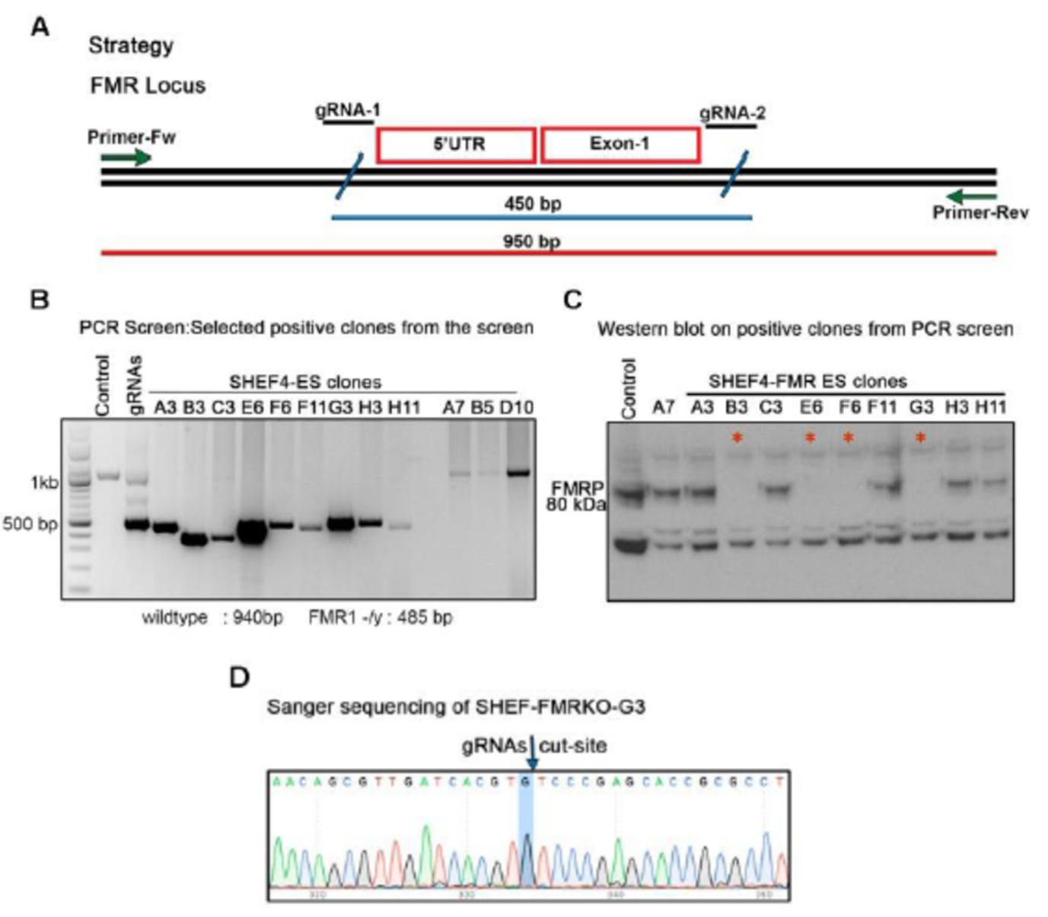

Figure 1: FMR-1 null ES and FXS IPS model system. A) The strategy for producing the FMR-1 null ES with the position of the guide RNA for CRISPR/CAS9 mediated deletion. B) PCR screening of the clones. The positive clones have PCR amplicon of around 450bps and the negative clones have the PCR amplicon of about 100bp. C) FMRP western blot for screening the positive clones for absence of FMRP expression at protein level. The positive clones are marked by *. D) Representative Sanger sequence of the FMR-1 null ES clone G3.

A

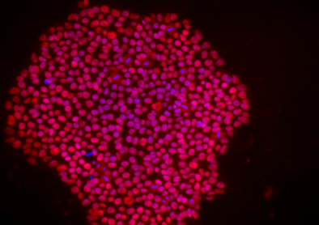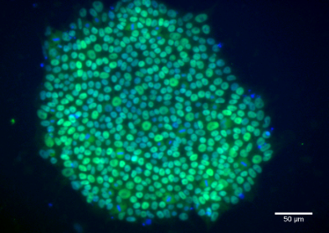

**NANOG/DAPI**

**OCT3/4/DAPI**

FMRP

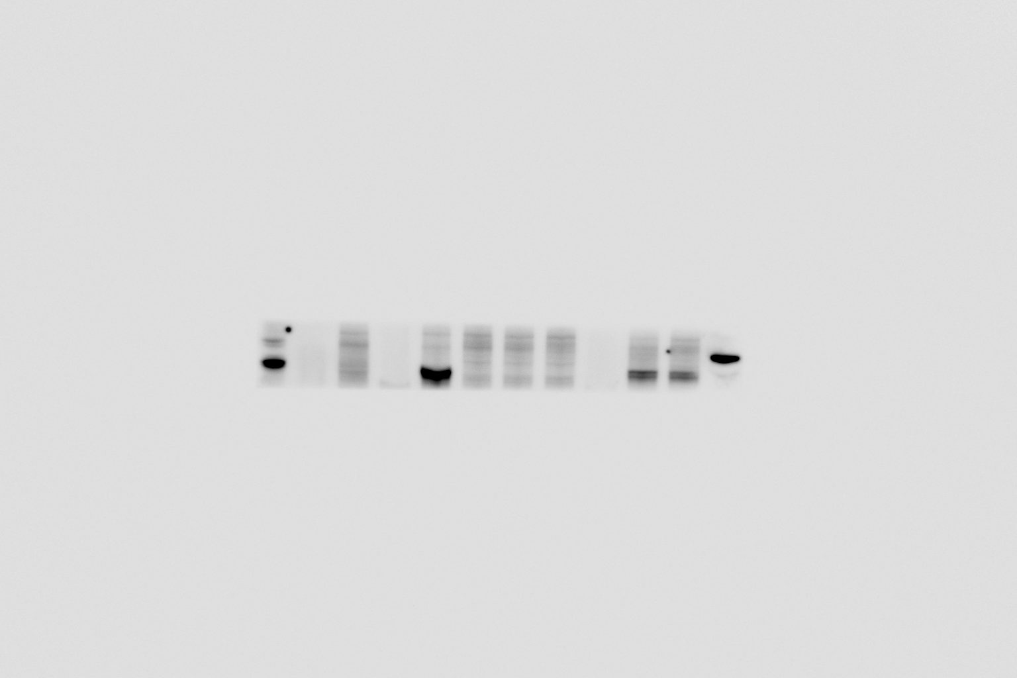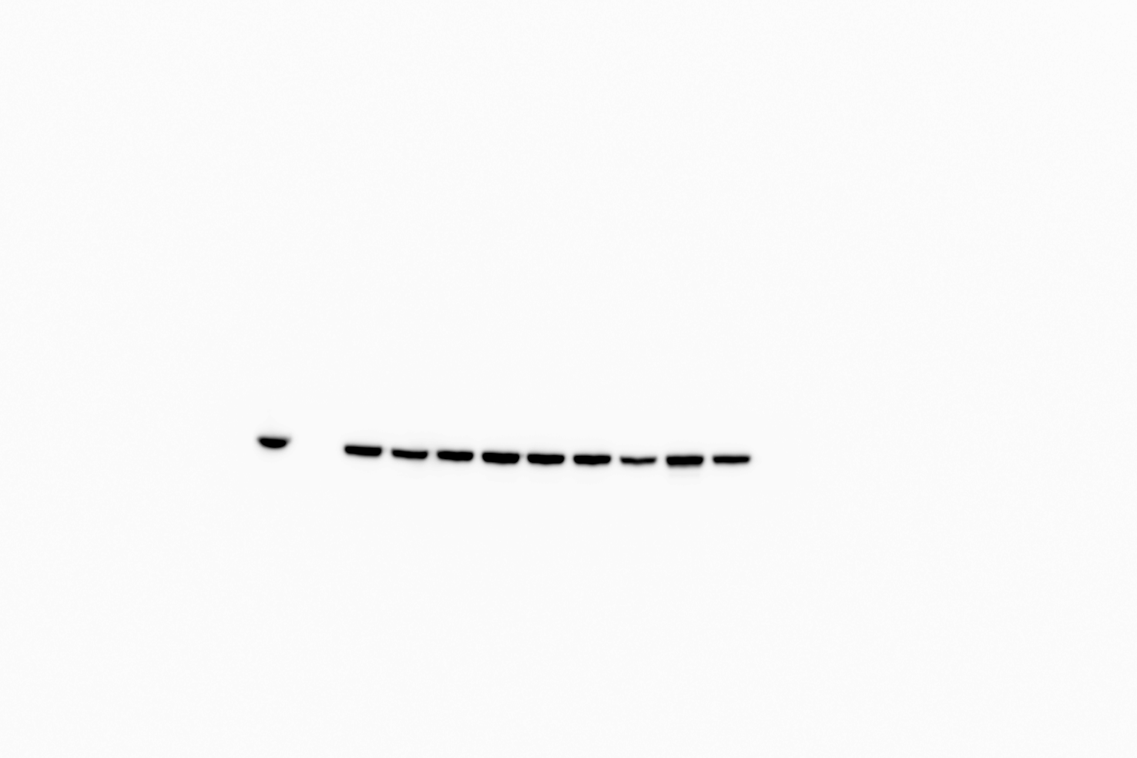

Cntrl1 Cntrl 2 FXS1 FXS2 FXS4 FXS3 ES FMRnull Blank Rat Brain lysate

β-Actin

B

Figure 2: Characterization of PS. A) Representative staining identifies Nanog and Oct3/4 positive PS. Scale bar 50um. B) FMRP Western blot of the FXS IPS, FMR-1 null ES, control IPS and control ES, FMR-1 null ES and FXS IPS showing the absence of FMRP.

1. Generation and basic characterization of oligodendrocytes from mutant and control PS

Oligodendrocytes were generated using the 90-day protocol previously described (Fig. 3A) from FXS IPS 1-4, FMR-1 null 1-2, control IPS 1-2 and control ES. Overall, there were no differences in the efficiency of specification to oligoprogenitors and oligodendrocytes (figure 3). Quantitative flow cytometry performed 1 week after differentiation revealed that cultures gave rise to a majority of (Fig. 3C, 4C) O4-labeled oligodendrocytes (ES, 48±5%; control IPS1, 45±4%; control IPS2, 47±4%; FMR-1 null1, 44±4%; FMR-1 null2, 46±4%; FXS IPS1, 44±5%; FXS IPS2, 45±4%; FXS IPS3, 45±7%; FXS IPS4, 46±4%). Notably, O4+ oligodendrocytes exhibited high co-expression of myelin basic protein (MBP) on immunocytochemistry (ES, 85±5%; control IPS1, 80±4%; control IPS2, 84±5%; FMR-1 null1, 79±5%; FMR-1 null2, 78±4%; FXS IPS1, 78±4%; FXS IPS2, 80±4%; FXS IPS3, 85±4%; FXS IPS4, 81±6%).

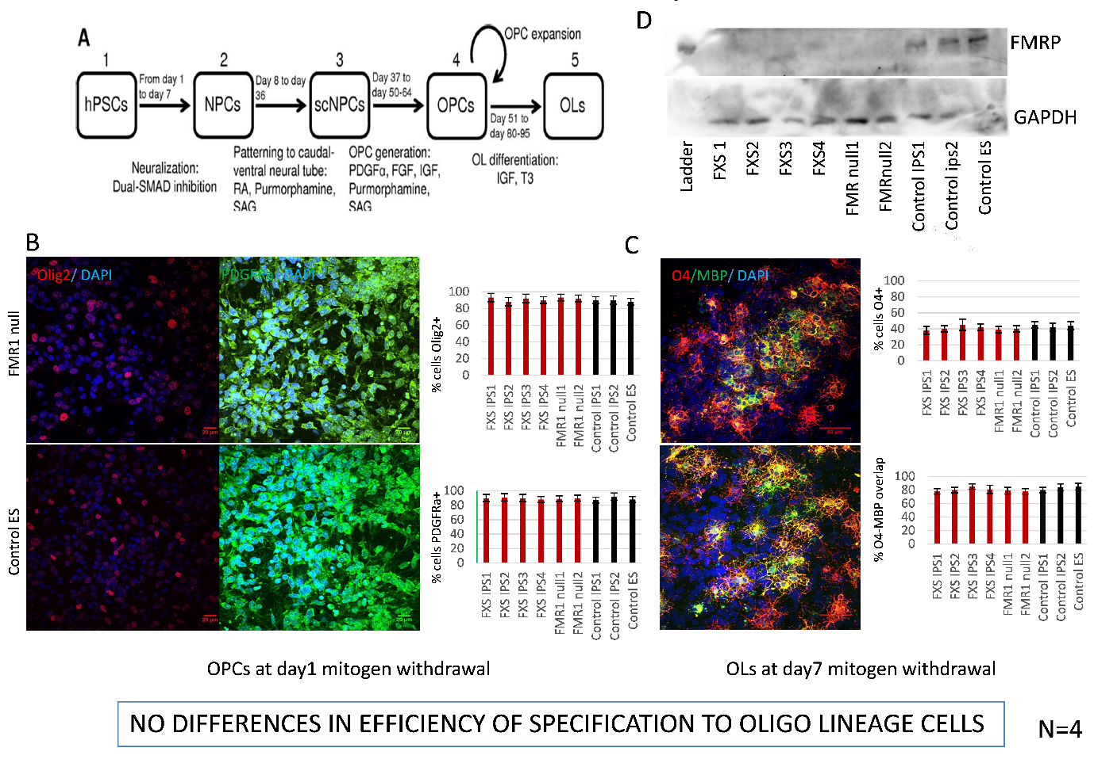

Figure 3: Efficiency of specification of oligoprogenitors and oligodendrocytes. A) Schematic of the 90-day protocol used to generate oligodendrocytes from PS. B) Left panel: Representative staining of cells 1-day post-mitogen removal identifies OLIG2+ and PDGFRa+ progenitors. Scale bar 20 um. Right panel: Percentage of OLIG2+ cells PDGFRa+ cells in day 1 cultures. C) Left panel: Representative staining of cells 1-week post-mitogen removal identifies O4+ and MBP+ progenitors. Scale bar 50 um. Right panel: Percentage of O4+ cells and O4-MBP overlap in day 7 cultures. D) FMRP Western blot of the oligodendrocytes derived from FXS IPS, FMR-1 null ES, control IPS and control ES, FMR-1 null ES and FXS IPS derived oligodendrocytes showing the absence of FMRP. Abbreviations: DAPI, 4’,6-diamidino-2-phenylindole; MBP, myelin basic protein; PDGFRa, platelet derived growth receptor alpha.

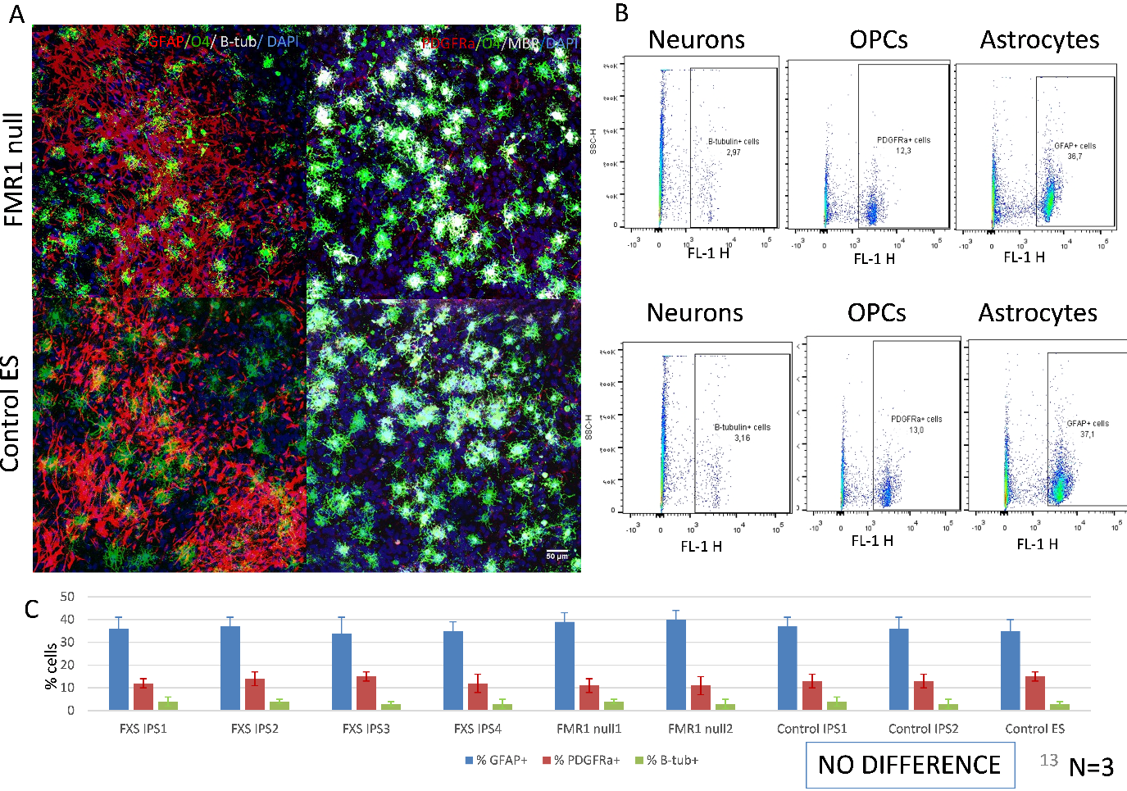Figure 4: Non-oligodendrocytes in 1-week cultures. A) Representative staining of cells 7-day post-mitogen removal identifies GFAP+ astrocytes, PDGFRa+ oligoprogenitors and Beta-tubulin+ neurons. Scale bar 20 um. B) Representative quantification of cells using flow cytometry. C) Percentage of GFAP+ astrocytes, PDGFRa+ oligoprogenitors and Beta-tubulin+ neurons in day 7 cultures. Abbreviations: DAPI, 4’,6-diamidino-2-phenylindole; MBP, myelin basic protein; PDGFRa, platelet derived growth receptor alpha, GFAP, glial fibrillary acidic protein.

It was noted that the FXS IPS and FMR-1 null ES derived oligodendrocytes stayed in culture for a shorter duration that those derived from controls (figure 5). The cells were seen to float off within 9.2±1.6 days in the mutant cell lines (FMR-1 null1, 8±2; FMR-1 null2, 8±2; FXS IPS1, 10±3; FXS IPS2, 9±3%; FXS IPS3, 12±5; FXS IPS4, 8±3), whereas they floated off after 20.3±0.6 days in control cell lines (ES, 21±3; control IPS1, 20±2%; control IPS2, 20±2). However, cellular proliferation rates (figure 6) and viability (figure 7) were not different across mutant and control oligodendrocytes. 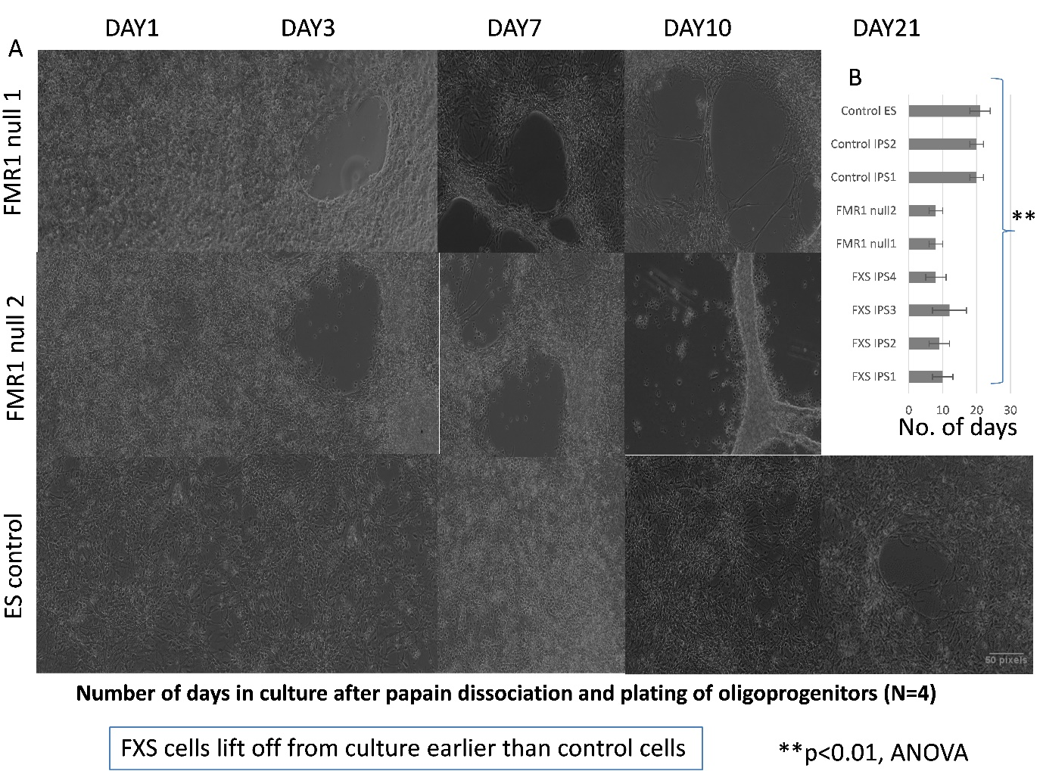

Figure 5: Oligoprogenitor platedowns from FXS/FMR1 null background stay in culture for shorter duration. A) Representative phase contrast images at specific time points from day 1-21. B) Quantification of the number of days that each cell line stayed in culture before floating off.

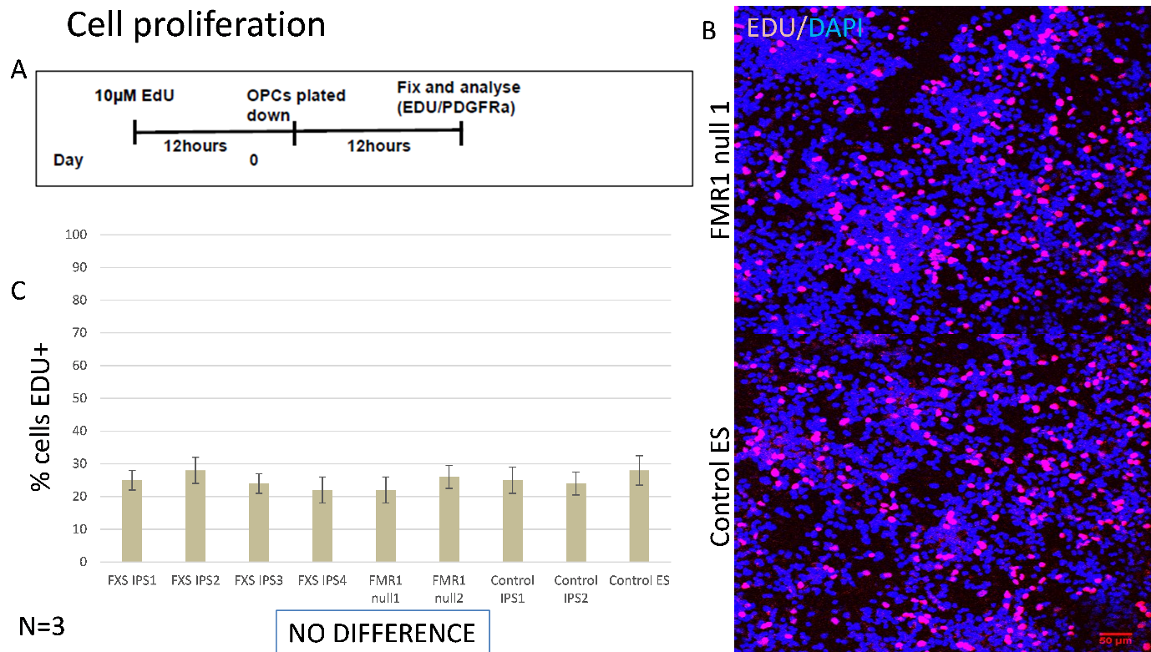

Figure 6: Cell proliferation assay in oligodendrocyte lineage cells. A) Protocol used to examine cellular proliferation at 12 hours after platedowns. B) Representative staining at 12 hours identifies EdU+ cells in the S phase of cell cycle. Scale bar 50um. C) Percentage of EdU+ cells at 12 hours. Abbreviations: DAPI, 4’,6-diamidino-2-phenylindole; EdU, 5-ethynyl-2’-deoxyuridine, OPC, oligoprogenitor cells.

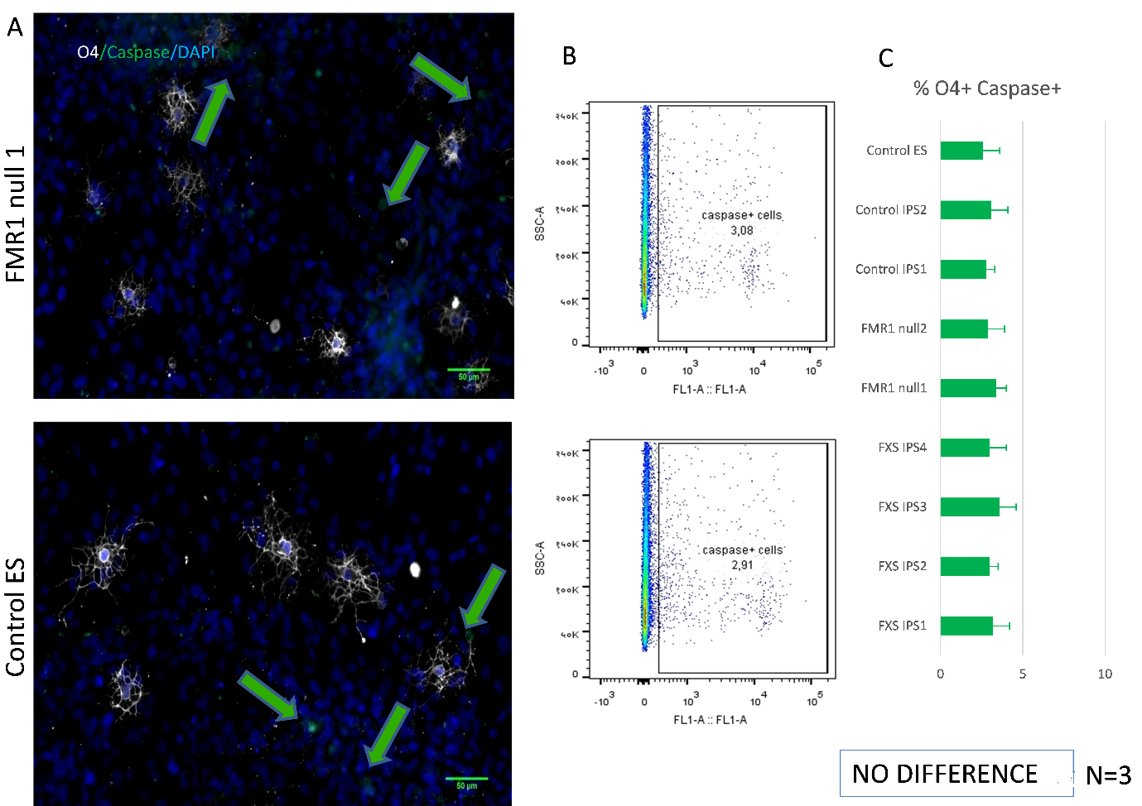

Figure 7: Viability analysis of oligodendrocytes at 1 week using Cell event Caspase 3/7 reagent. A) Representative staining of O4+ oligodendrocytes and Caspase+ apoptotic cells in day 7 cultures. Scale bar 50um. B) Quantitative flow cytometry in day 7 oligodendrocytes. C) Percentage of Caspase+ cells in day 7 oligodendrocytes.

1. Morphology of oligodendrocytes

O4+ positive oligodendrocytes display unique morphology with many elongated and branching processes. The morphology of O4+ cells were compared between mutant and control lines using Sholl analysis. Oligodendrocytes from FXS/ FMR1 null background were morphologically different from those from controls. They were found to have reduced arborization in Sholl analysis (figure 8). This analysis was done using high magnification images (63x). One obvious question was whether this morphological difference is due to differences in cell health/ viability. As previously described, this was examined in day 7 cultures (figure 7), but no differences were found between mutant and control lines.

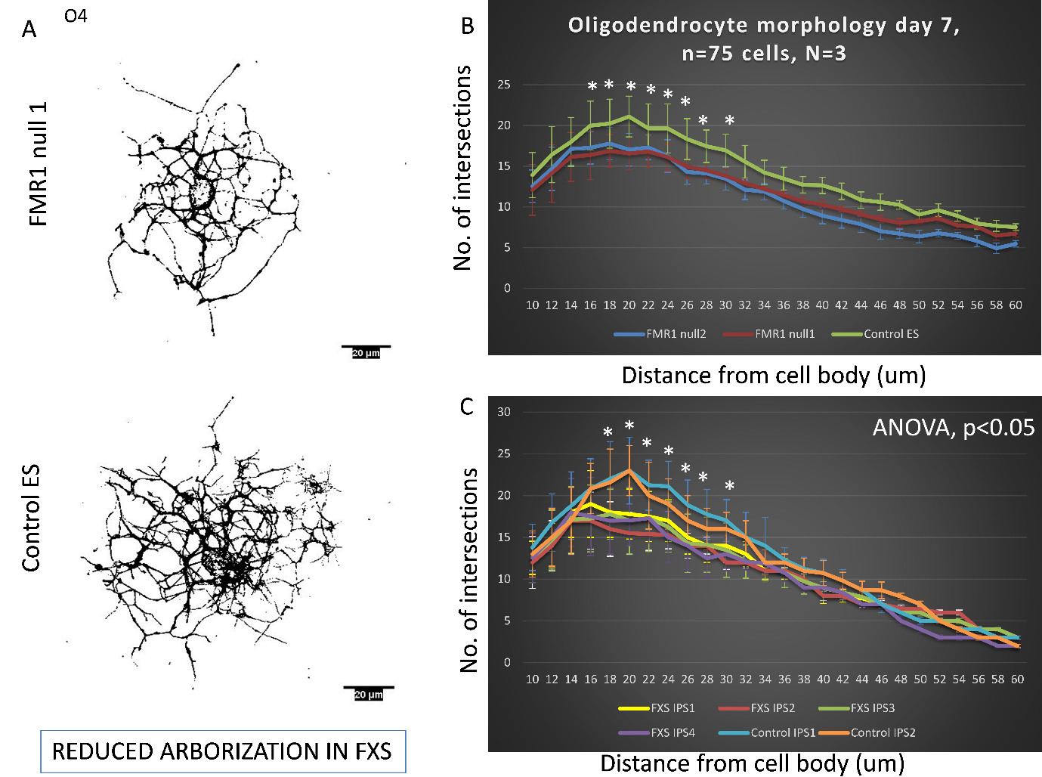

Figure 8: Sholl analysis performed upon week 1 O4+ oligodendrocytes. A) Representative thresholded images of O4+ cells at day 7. Scale bar 20um. B) Comparison of morphology between FMR1-null ES and control ES derived oligodendrocytes. C) Comparison of morphology between FXS IPS and control IPS derived oligodendrocytes.

1. Glycolytic assay in oligodendrocytes

Differences in glycolytic capacity have been known to cause cell death and process retraction in oligodendrocytes (43). Hence, the metabolic function of oligodendrocytes (glycolysis stress test) was assessed using the Seahorse bioanalyzer in day 7, to examine differences between mutant and control oligodendrocytes in glycolytic function (figure 9A).

The conversion of glucose to pyruvate during glycolysis, and subsequently lactate, results in a net production and extrusion of protons into the extracellular medium. The extrusion of protons results in the acidification of the medium surrounding the cell. The XF instrument directly measures the extracellular acidification rate (ECAR). The assay workflow is as follows. First, cells are incubated without glucose or pyruvate and the ECAR is measured. The first injection is a saturating concentration of glucose. The cells utilize the glucose injection and catabolize it through the glycolytic pathway, causing a rapid increase in ECAR, which is reported as the rate of basal glycolysis. The second injection is oligomycin, an ATP synthase inhibitor. Oligomycin inhibits mitochondrial ATP production, and shifts the energy production to glycolysis. This increase in ECAR is the maximum glycolytic capacity. The final injection is 2-deoxy-glucose (2-DG), a glucose analog, that inhibits glycolysis through competitive binding to glucose hexokinase. The difference between glycolytic capacity and glycolysis rate is the glycolytic reserve. The ratio of glycolytic reserve to glycolytic capacity expressed as percentage is called the glycolytic reserve percentage.

There were no differences across groups with respect to basal glycolysis, glycolytic reserve capacity and glycolytic reserve. However, there was significant difference found in terms of glycolytic reserve percentage, with mutant cultures exhibiting higher values in comparison to controls (figure 9B-C). A higher level of glycolysis reserve percentage is usually shown by cells which are undergoing any form of stress.

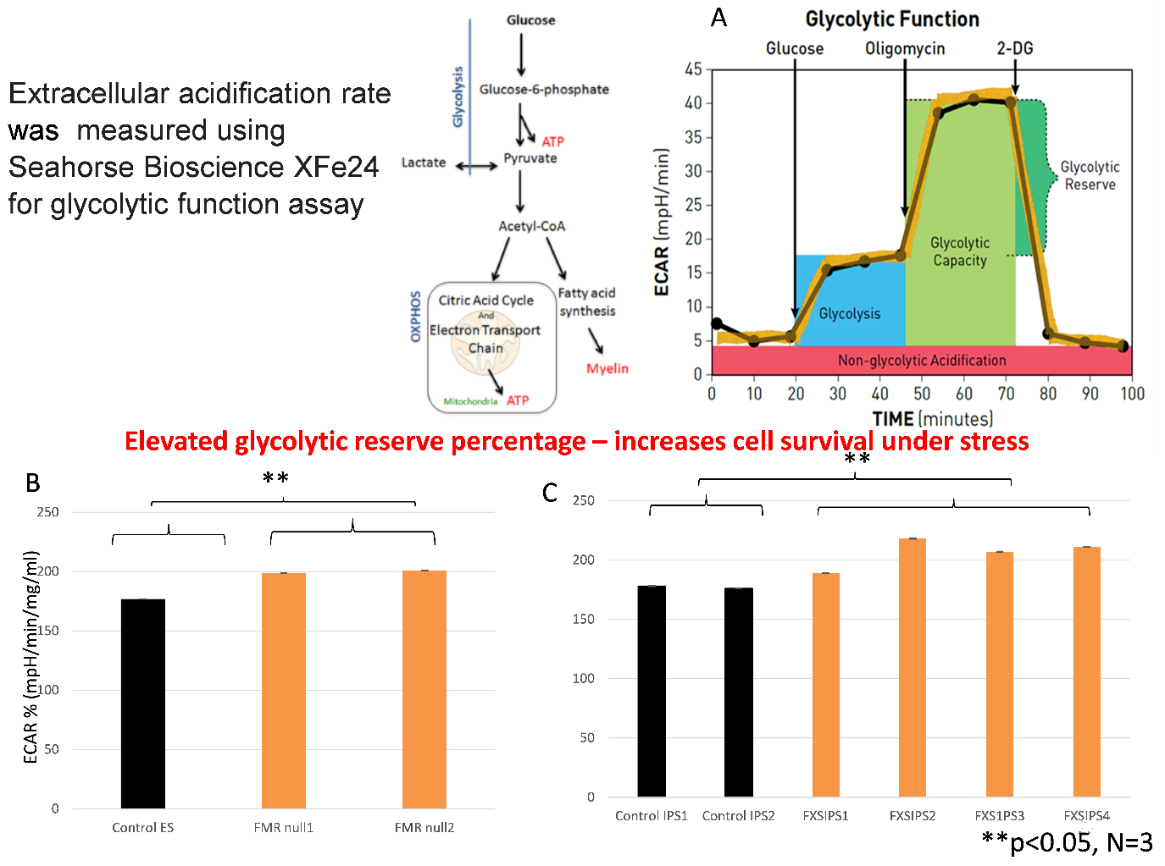 Figure 9: Glycolysis stress test of oligodendrocytes at 1 week. A) Extracellular acidification is measured by serial addition of glucose, oligomycin and 1-deoxyglucose to measure glycolysis, glycolytic capacity and glycolytic reserve, respectively. B) Quantification of extracellular acidification rate between FMR-1 null ES and control ES derived oligodendrocytes. C) Quantification of extracellular acidification rate between FXS IPS and control IPS derived oligodendrocytes. Abbreviations: ECAR, extracellular acidification rate, 2DG, 2-deoxy glucose.

1. Electrophysiology of oligodendrocytes

The electrophysiological properties of oligodendrocytes were examined with whole-cell patch-clamp recording. The maturation of oligodendrocytes from OPCs (identified using O4 live-staining) recapitulates the equivalent process in rodents (40, 41) by demonstrating a developmental reduction in the outward rectification of sustained voltage-dependent currents (39). Patient and control lines were compared in terms of maturity of current responses the degree of shift in current rectification at week 1 O4*+*-oligodendrocytes (figure 10). Preliminary experiments did not reveal any differences across groups with respect to capacitance and input resistance.

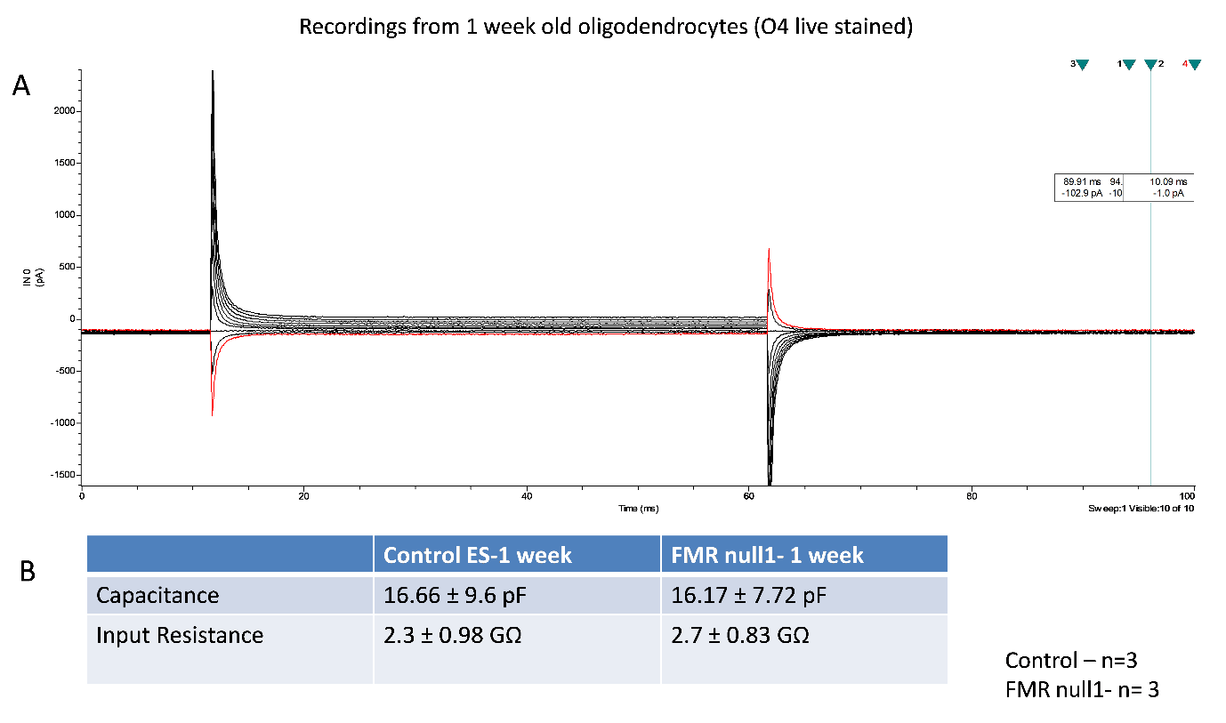

Figure 10: Electrophysiology of 1-week old oligodendrocytes. A) Whole‐cell current recordings from week 1 O4+‐oligodendrocyte in response to a voltage‐step protocol that involved incremental application of 20 mV voltage steps from a holding potential of –84 mV. B) Quantification of input resistance and capacitance across FMR-1 null ES and control ES derived oligodendrocytes.

1. Myelination assay

Co-culture of PS derived cortical neurons and oligodendrocytes was performed to examine myelination. Anterior neural precursors were generated from IPSs by dual SMAD inhibition. Further, neuronal differentiation was initiated by the removal of FGF2 and cultures maintained in a 3% O2 atmosphere (42). Oligo-spheres were dissociated with papain and the oligoprogenitors were allowed to grow on neuronal cultures for 2 weeks with 1:1 proportion of oligo differentiation and neural differentiation media. The morphology of MBP+ cells were compared between FMR1 null and control lines using Sholl analysis. Oligodendrocytes from FXS/ FMR1 null background were different from those from controls in terms of myelin arborization. They were found to have reduced arborization in Sholl analysis (figure. 11).

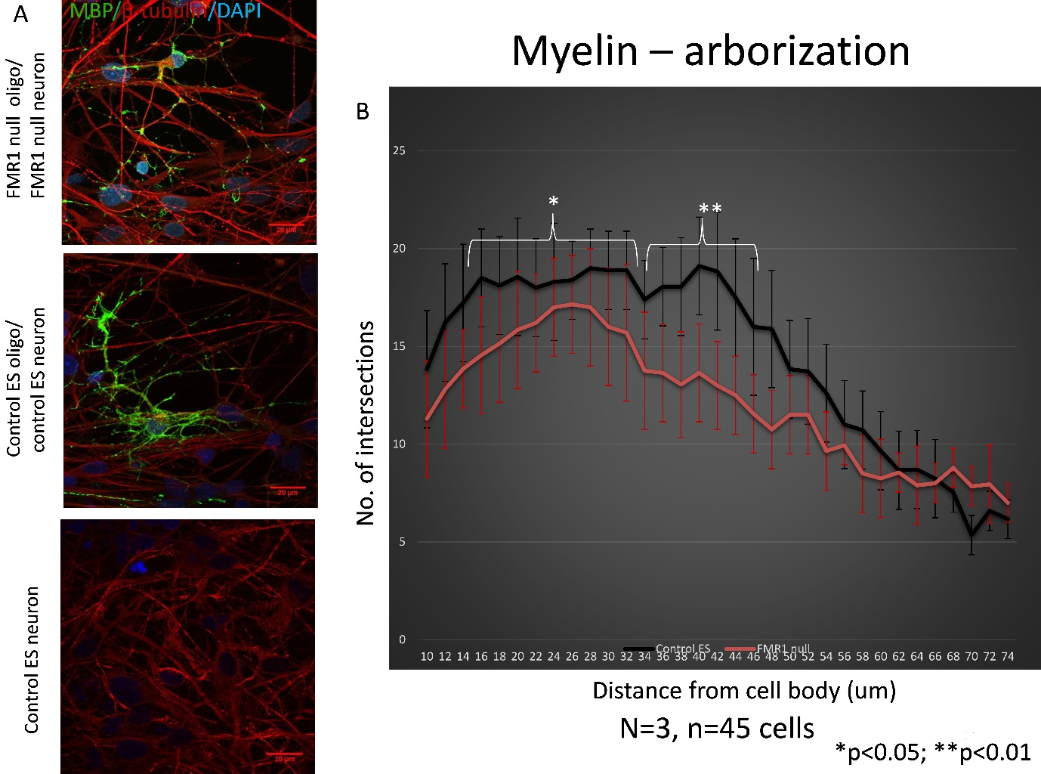

Figure 11: Arborization of myelin in oligodendrocytes co-cultured with IPS derived neurons for 14 days. A) Representative staining of MBP+ oligodendrocytes cultured on β-tubulin+ neurons on day 14. Scale bar 20um. B) Comparison of myelin arborization between FMR1-null ES and control ES derived oligodendrocytes on day 14.

**SUMMARY**

Human diffusion tensor imaging studies and knockout rodent studies have identified myelin abnormalities in fragile X syndrome (FXS). Oligodendrocytes are the myelin producing cells in the human brain. However, the role of oligodendrocytes in FXS has not been examined in a human model system. We used oligodendrocytes derived from induced pluripotent stem cells *(*IPS*)* of patients with FXS *(*N=4*)* and controls *(*N=2*)* to examine this question. The role of FMRP was further confirmed using CRISPR edited FMR1 null embryonic stem cells *(*ES*)* and paired control.

There were no differences in the efficiency of specification to oligoprogenitors and oligodendrocytes, cell proliferation or viability. Differentiated oligodendrocytes from FXS/FMR1 null background were morphologically different from control cells with significant reduction of branches at one week post mitogen withdrawal. Differences in glycolytic capacity have been known to cause process retraction in oligodendrocytes. Seahorse assays *(*glycolysis stress test) revealed significant difference between FMR1 null and control lines in terms of glycolysis reserve percentage.

Metabolic and morphological differences oligodendrocytes from FXS/ FMR1 null background indicate that these cells may have reduced ability to myelinate neurons.This was directly examined using *invitro* myelination assay with human oligodendrocyte – human neuron co-cultures, with FMR1 null oligodendrocytes showing reduced myelin arborization.

To summarize, we have directly examined the role of FXS on oligodendrocytes using FXS IPS and FMR1 null ES with paired controls and identified clear cellular phenotypes of defective morphology, metabolism and myelination. The next step is to understand the molecular basis of the above cellular phenotypes using transcriptome and proteome analyses.

**REFERENCES**

1. Mullin AP, Gokhale A, Moreno-De-Luca A, Sanyal S, Waddington JL, Faundez V. Neurodevelopmental disorders: mechanisms and boundary definitions from genomes, interactomes and proteomes. Transl Psychiatry. 2013 Dec 3;3: e329.

2. Jakovcevski I, Mo Z, Zecevic N. Down-regulation of the axonal polysialic acid-neural cell adhesion molecule expression coincides with the onset of myelination in the human fetal forebrain. Neuroscience. 2007 Oct 26;149(2):328-37.

3. Jakovcevski I, Filipovic R, Mo Z, Rakic S, Zecevic N. Oligodendrocyte development and the onset of myelination in the human fetal brain. Front Neuroanat. 2009; 3:5.

4. Dawson J, Hotchin N, Lax S, Rumsby M. Lysophosphatidic acid induces process retraction in CG-4 line oligodendrocytes and oligodendrocyte precursor cells but not in differentiated oligodendrocytes. J Neurochem. 2003 Nov;87(4):947-57.

5. Back SA, Luo NL, Borenstein NS, Levine JM, Volpe JJ, Kinney HC. Late oligodendrocyte progenitors coincide with the developmental window of vulnerability for human perinatal white matter injury. J Neurosci. 2001 Feb 15;21(4):1302-12.

6. Jakovcevski I, Zecevic N. Sequence of oligodendrocyte development in the human fetal telencephalon. Glia. 2005 Mar;49(4):480-91.

7. Rakic S, Zecevic N. Early oligodendrocyte progenitor cells in the human fetal telencephalon. Glia. 2003 Jan 15;41(2):117-27.

8. Rivkin MJ, Flax J, Mozell R, Osathanondh R, Volpe JJ, Villa-Komaroff L. Oligodendroglial development in human fetal cerebrum. Ann Neurol. 1995 Jul;38(1):92-101.

9. Bergles DE, Roberts JD, Somogyi P, Jahr CE. Glutamatergic synapses on oligodendrocyte precursor cells in the hippocampus. Nature. 2000 May 11;405(6783):187-91.

10. Butt AM, Duncan A, Hornby MF, Kirvell SL, Hunter A, Levine JM, et al. Cells expressing the NG2 antigen contact nodes of Ranvier in adult CNS white matter. Glia. 1999 Mar;26(1):84-91.

11. Lin S, Fan LW, Pang Y, Rhodes PG, Mitchell HJ, Cai Z. IGF-1 protects oligodendrocyte progenitor cells and improves neurological functions following cerebral hypoxia-ischemia in the neonatal rat. Brain Res. 2005 Nov 23;1063(1):15-26.

12. Nishiyama A, Komitova M, Suzuki R, Zhu X. Polydendrocytes (NG2 cells): multifunctional cells with lineage plasticity. Nat Rev Neurosci. 2009 Jan;10(1):9-22.

13. Lee Y, Morrison BM, Li Y, Lengacher S, Farah MH, Hoffman PN, et al. Oligodendroglia metabolically support axons and contribute to neurodegeneration. Nature. Jul 26;487(7408):443-8.

14. Rinholm JE, Bergersen LH. Neuroscience: The wrap that feeds neurons. Nature. Jul 25;487(7408):435-6.

15. Reiss AL, Hagerman RJ, Vinogradov S, Abrams M, King RJ. Psychiatric disability in female carriers of the fragile X chromosome. Arch Gen Psychiatry. 1988 Jan;45(1):25-30.

16. Giampetruzzi A, Carson JH, Barbarese E. FMRP and myelin protein expression in oligodendrocytes. Mol Cell Neurosci. 2013 Sep; 56:333-41.

17. Wang H, Ku L, Osterhout DJ, Li W, Ahmadian A, Liang Z, et al. Developmentally-programmed FMRP expression in oligodendrocytes: a potential role of FMRP in regulating translation in oligodendroglia progenitors. Hum Mol Genet. 2004 Jan 1;13(1):79-89.

18. Pacey LK, Xuan IC, Guan S, Sussman D, Henkelman RM, Chen Y, et al. Delayed myelination in a mouse model of fragile X syndrome. Hum Mol Genet. 2013 Oct 1;22(19):3920-30.

19. Darnell JC, Van Driesche SJ, Zhang C, Hung KY, Mele A, Fraser CE, et al. FMRP stalls ribosomal translocation on mRNAs linked to synaptic function and autism. Cell. 2011 Jul 22;146(2):247-61.

20. Li Z, Zhang Y, Ku L, Wilkinson KD, Warren ST, Feng Y. The fragile X mental retardation protein inhibits translation via interacting with mRNA. Nucleic Acids Res. 2001 Jun 1;29(11):2276-83.

21. Haberl MG, Zerbi V, Veltien A, Ginger M, Heerschap A, Frick A. Structural-functional connectivity deficits of neocortical circuits in the Fmr1 (-/y) mouse model of autism. Sci Adv. 2015 Nov;1(10): e1500775.

22. Haas BW, Barnea-Goraly N, Lightbody AA, Patnaik SS, Hoeft F, Hazlett H, et al. Early white-matter abnormalities of the ventral frontostriatal pathway in fragile X syndrome. Dev Med Child Neurol. 2009 Aug;51(8):593-9.

23. Hall SS, Dougherty RF, Reiss AL. Profiles of aberrant white matter microstructure in fragile X syndrome. Neuroimage Clin. 2016; 11:133-8.

24. Villalon-Reina J, Jahanshad N, Beaton E, Toga AW, Thompson PM, Simon TJ. White matter microstructural abnormalities in girls with chromosome 22q11.2 deletion syndrome, Fragile X or Turner syndrome as evidenced by diffusion tensor imaging. Neuroimage. 2013 Nov 1; 81:441-54.

25. Swanson MR, Wolff JJ, Shen MD, Styner M, Estes A, Gerig G, et al. Development of White Matter Circuitry in Infants with Fragile X Syndrome. JAMA Psychiatry. 2018 May 1;75(5):505-13.

26. Filley CM, Brown MS, Onderko K, Ray M, Bennett RE, Berry-Kravis E, et al. White matter disease and cognitive impairment in FMR1 premutation carriers. Neurology. 2015 May 26;84(21):2146-52.

27. Hashimoto R, Srivastava S, Tassone F, Hagerman RJ, Rivera SM. Diffusion tensor imaging in male premutation carriers of the fragile X mental retardation gene. Mov Disord. Jun;26(7):1329-36.

28. Hippolyte L, Battistella G, Perrin AG, Fornari E, Cornish KM, Beckmann JS, et al. Investigation of memory, executive functions, and anatomic correlates in asymptomatic FMR1 premutation carriers. Neurobiol Aging. 2014 Aug;35(8):1939-46.

29. Shelton AL, Cornish KM, Godler D, Bui QM, Kolbe S, Fielding J. White matter microstructure, cognition, and molecular markers in fragile X premutation females. Neurology. May 30;88(22):2080-8.

30. Wang JY, Hessl D, Schneider A, Tassone F, Hagerman RJ, Rivera SM. Fragile X-associated tremor/ataxia syndrome: influence of the FMR1 gene on motor fiber tracts in males with normal and premutation alleles. JAMA Neurol. 2013 Aug;70(8):1022-9.

31. Wang JY, Hessl DH, Hagerman RJ, Tassone F, Rivera SM. Age-dependent structural connectivity effects in fragile x premutation. Arch Neurol. 2012 Apr;69(4):482-9.

32. Chandran S, Svendsen C, Compston A, Scolding N. Regional potential for oligodendrocyte generation in the rodent embryonic spinal cord following exposure to EGF and FGF-2. Glia. 1998 Dec;24(4):382-9.

33. Gaughwin PM, Caldwell MA, Anderson JM, Schwiening CJ, Fawcett JW, Compston DA, et al. Astrocytes promote neurogenesis from oligodendrocyte precursor cells. Eur J Neurosci. 2006 Feb;23(4):945-56.

34. Stacpoole SR, Spitzer S, Bilican B, Compston A, Karadottir R, Chandran S, et al. High yields of oligodendrocyte lineage cells from human embryonic stem cells at physiological oxygen tensions for evaluation of translational biology. Stem Cell Reports. 2013;1(5):437-50.

35. Webber DJ, Compston A, Chandran S. Minimally manipulated oligodendrocyte precursor cells retain exclusive commitment to the oligodendrocyte lineage following transplantation into intact and injured hippocampus. Eur J Neurosci. 2007 Oct;26(7):1791-800.

36. Webber DJ, van Blitterswijk M, Chandran S. Neuroprotective effect of oligodendrocyte precursor cell transplantation in a long-term model of periventricular leukomalacia. Am J Pathol. 2009 Dec;175(6):2332-42.

37. Wilkins A, Chandran S, Compston A. A role for oligodendrocyte-derived IGF-1 in trophic support of cortical neurons. Glia. 2001 Oct;36(1):48-57.

38. Wilkins A, Majed H, Layfield R, Compston A, Chandran S. Oligodendrocytes promote neuronal survival and axonal length by distinct intracellular mechanisms: a novel role for oligodendrocyte-derived glial cell line-derived neurotrophic factor. J Neurosci. 2003 Jun 15;23(12):4967-74.

39. Livesey MR, Magnani D, Cleary EM, Vasistha NA, James OT, Selvaraj BT, et al. Maturation and electrophysiological properties of human pluripotent stem cell-derived oligodendrocytes. Stem Cells. 2016 Apr;34(4):1040-53.

40. Sontheimer H, Trotter J, Schachner M, Kettenmann H. CHANNEL EXPRESSION CORRELATES WITH DIFFERENTIATION STAGE DURING THE DEVELOPMENT OF OLIGODENDROCYTES FROM THEIR PRECURSOR CELLS IN CULTURE. Neuron. 1989 Feb;2(2):1135-45.

41. Tripathi RB, Clarke LE, Burzomato V, Kessaris N, Anderson PN, Attwell D, et al. Dorsally and Ventrally Derived Oligodendrocytes Have Similar Electrical Properties but Myelinate Preferred Tracts. Journal of Neuroscience. 2011 May 4;31(18):6809-19.

42. Bilican B, Livesey MR, Haghi G, Qiu J, Burr K, Siller R, et al. Physiological normoxia and absence of EGF is required for the long-term propagation of anterior neural precursors from human pluripotent cells. PLoS One. 2014;9(1): e85932.

43. Rone MB, Cui QL, Fang J, Wang LC, Zhang J, Khan D, et al. Oligodendrogliopathy in Multiple Sclerosis: Low Glycolytic Metabolic Rate Promotes Oligodendrocyte Survival. J Neurosci. 2016 Apr 27;36(17):4698-707.